Institute of Computer Technology

B. Tech Computer Science and Engineering

Subject: DS (2CSE302)

**PRACTICAL-7**

**AIM: - Implement the scenario based on string.**

**1. Rishi has prepared the document regarding data of employee for Temko.pvt.ltd company. He has written text “Ramankrupali” instead of “Ramanujacharya”. So he need to correct as per following using c code:**

**Enter the String: Ramankrupali**

**Enter string which you want to delete: krupali**

**Enter new string: ujacharya**

**Enter location where you want to insert: 5**

**Updated String: Ramanujacharya**

***SOLUTION***

#include <stdio.h>

#include <string.h>

int main()

{

int i = 0, j = 0, count = 0, location = 0, count1 = 0 , l=0;

char yash[20], del[20], name[20], new_name[20], main_str[20];

printf("Enter The string: ");

scanf("%s", yash);

printf("Enter String Which You Want To Delete: ");

scanf("%s", del);

while (yash[i] != '\0')

{

if (yash[i] == del[j])

{

while (del[j] != '\0')

{

i++;

j++;

}

}

else

{

name[i] = yash[i];

i++;

count++;

}

}

name[count] = '\0';

printf("Updated String: %s", name);

printf("\n\nEnter New String: ");

scanf("%s", new_name);

printf("Enter Location Where You Want To Insert: ");

scanf("%d", &location);

i=0;j=0;

l = strlen(name) + strlen(new_name);

while (i < l)

{

if (i == location)

{

while (new_name[j] != '\0')

{

main_str[i] = new_name[j];

j++;

i++;

}

}

main_str[i] = name[count1];

i++;

count1++;

}

printf("Updated String: %s\n", main_str);

return 0;

}

***OUTPUT***

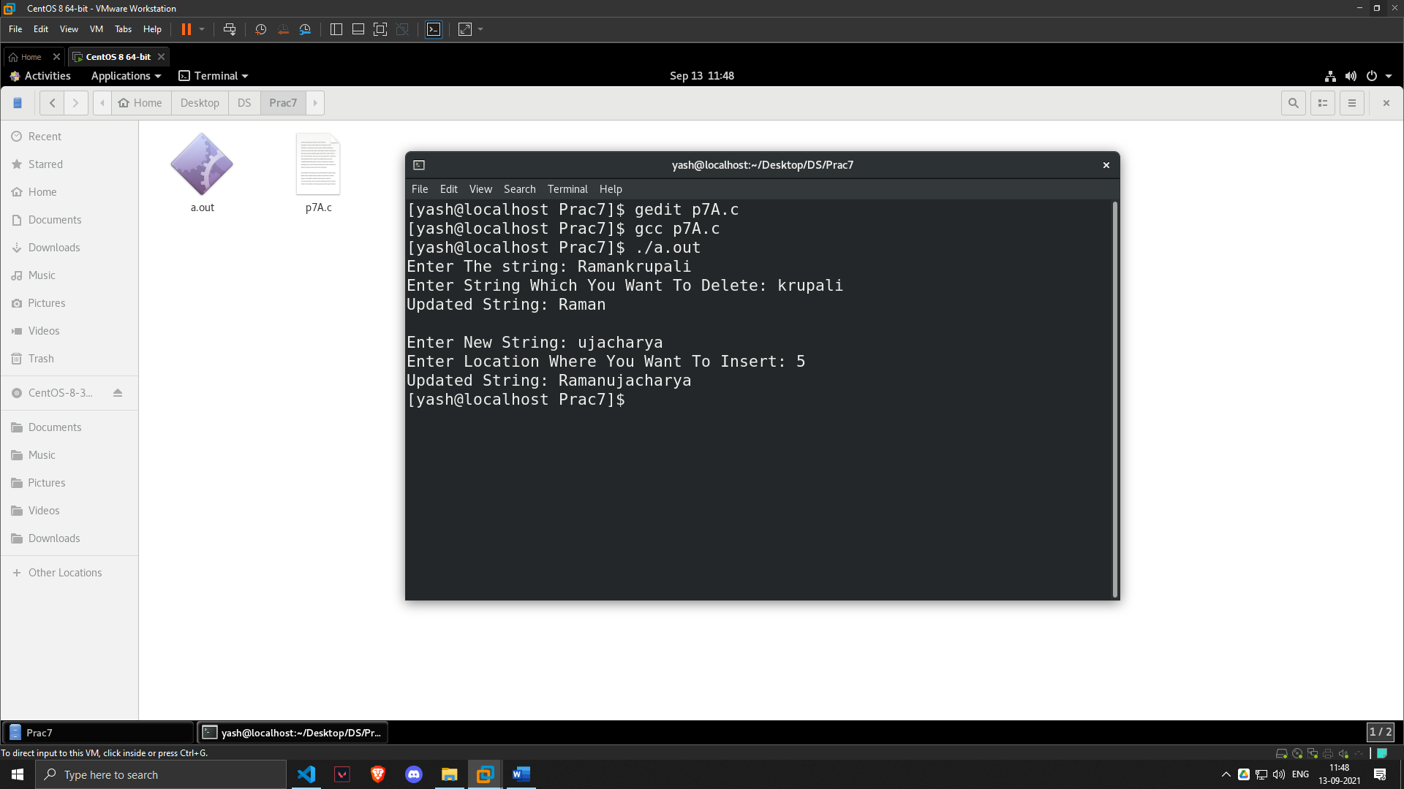

**2. Also he wants to convert string into uppercase to lowercase. So first he wants to create an algorithm for the same and then after he wants to develop the code as per the algorithm in c.**

***ALGORITHM***

1. Declare character array yash and integer variable i

2. Input string from user

3. While yash[i]!='\0' repeat step 4

4. If yash[i]>='A' && yash[i]<='Z' then yash[i]= yash[i]+32

5. i++

6. print the string

7. EXIT

***SOLUTION***

#include<stdio.h>

int main()

{

char yash[20],i=0;

printf("Enter string:");

scanf("%s",yash);

while(yash[i]!='\0')

{

if(yash[i]>='A' && yash[i]<='Z')

{

yash[i]=yash[i]+32;

}

i++;

}

printf("%s\n",yash);

return 0;

}

***OUTPUT***

